Week 5_3. Microservices composite handson
HandsOn_1. Creating Microservices for account and loan
AccountController.java
package com.cognizant.account.controller;

import org.springframework.web.bind.annotation.*;

import java.util.Map;

@RestController
@RequestMapping("/accounts")
public class AccountController {

@GetMapping("/{number}")
public Map<String, Object> getAccountDetails(@PathVariable String number) {
return Map.of(
"number", number,
"type", "savings",
"balance", 234343
);
}
}
AccountApplication.java
package com.cognizant.account;

import org.springframework.boot.SpringApplication;
import org.springframework.boot.autoconfigure.SpringBootApplication;

@SpringBootApplication
public class AccountApplication {
public static void main(String[] args) {
SpringApplication.run(AccountApplication.class, args);
}
}
application.properties
spring.application.name=account
server.port=8080
eureka.client.service-url.defaultZone=http://localhost:8761/eureka
AccountApplicationTests.java
package com.cognizant.account;

import org.junit.jupiter.api.Test;
import org.springframework.boot.test.context.SpringBootTest;

@SpringBootTest
class AccountApplicationTests {

@Test
void contextLoads() {
}

}
Discovery
DiscoveryApplication.java
package com.cognizant.discovery;

import org.springframework.boot.SpringApplication;
import org.springframework.boot.autoconfigure.SpringBootApplication;
import org.springframework.cloud.netflix.eureka.server.EnableEurekaServer;

@SpringBootApplication
@EnableEurekaServer
public class DiscoveryApplication {
public static void main(String[] args) {
SpringApplication.run(DiscoveryApplication.class, args);
}
}
application.properties
spring.application.name=discovery
server.port=8761

eureka.client.register-with-eureka=false
eureka.client.fetch-registry=false
DiscoveryApplicationTests.java
package com.cognizant.discovery;

import org.junit.jupiter.api.Test;
import org.springframework.boot.test.context.SpringBootTest;

@SpringBootTest
class DiscoveryApplicationTests {

@Test
void contextLoads() {
}

}
Loan
LoanController.java
package com.cognizant.loan.controller;

import org.springframework.web.bind.annotation.*;

import java.util.Map;

@RestController
@RequestMapping("/loans")
public class LoanController {

@GetMapping("/{number}")
public Map<String, Object> getLoanDetails(@PathVariable String number) {
return Map.of(
"number", number,
"type", "car",
"loan", 400000,
"emi", 3258,
"tenure", 18
);
}
}
LoanApplication.java
package com.cognizant.loan;

import org.springframework.boot.SpringApplication;
import org.springframework.boot.autoconfigure.SpringBootApplication;

@SpringBootApplication
public class LoanApplication {
public static void main(String[] args) {
SpringApplication.run(LoanApplication.class, args);
}
}
application.properties
spring.application.name=loan
server.port=8081
eureka.client.service-url.defaultZone=http://localhost:8761/eureka
LoanApplicationTests.java
package com.cognizant.loan;

import org.junit.jupiter.api.Test;
import org.springframework.boot.test.context.SpringBootTest;

@SpringBootTest
class LoanApplicationTests {

@Test
void contextLoads() {
}

}

OUTPUT
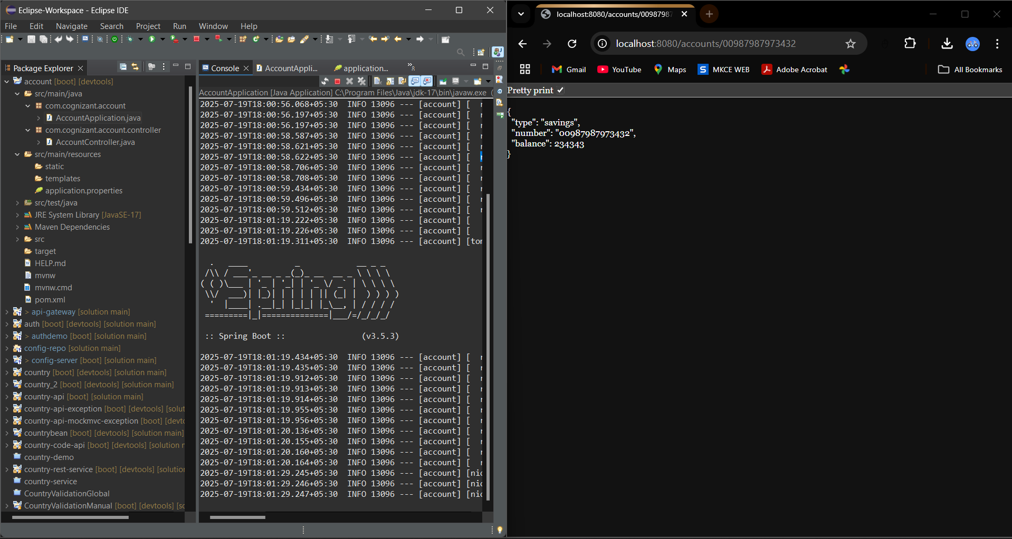
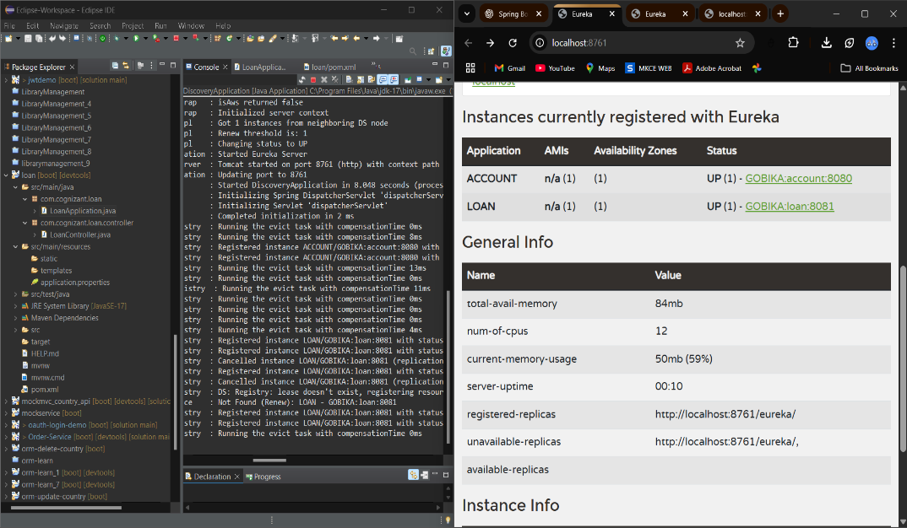
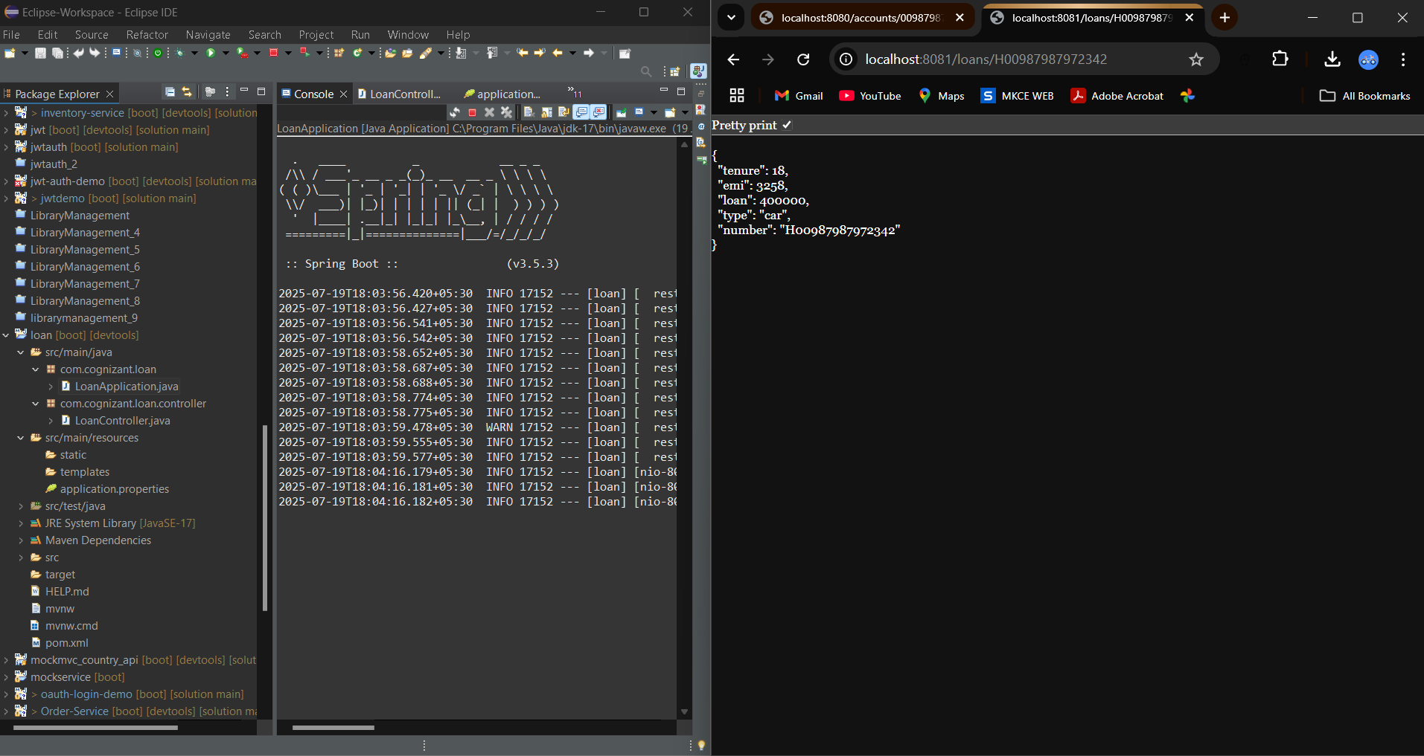
HandsOn_2. Create Eureka Discovery Server and register microservices
Account
AccountController.java
package com.cognizant.account.controller;

import org.springframework.web.bind.annotation.*;

import java.util.Map;

@RestController
@RequestMapping("/accounts")
public class AccountController {

@GetMapping("/{number}")
public Map<String, Object> getAccountDetails(@PathVariable String number) {
return Map.of(
"number", number,
"type", "savings",
"balance", 234343
);
}
}
AccountApplication.java
package com.cognizant.account;

import org.springframework.boot.SpringApplication;
import org.springframework.boot.autoconfigure.SpringBootApplication;

@SpringBootApplication
public class AccountApplication {
public static void main(String[] args) {
SpringApplication.run(AccountApplication.class, args);
}
}
application.properties
spring.application.name=account
server.port=8080
eureka.client.service-url.defaultZone=http://localhost:8761/eureka
AccountApplicationTests.java
package com.cognizant.account;

import org.junit.jupiter.api.Test;
import org.springframework.boot.test.context.SpringBootTest;

@SpringBootTest
class AccountApplicationTests {

@Test
void contextLoads() {
}

}
Loan
LoanController.java
package com.cognizant.loan.controller;

import org.springframework.web.bind.annotation.*;

import java.util.Map;

@RestController
@RequestMapping("/loans")
public class LoanController {

@GetMapping("/{number}")
public Map<String, Object> getLoanDetails(@PathVariable String number) {
return Map.of(
"number", number,
"type", "car",
"loan", 400000,
"emi", 3258,
"tenure", 18
);
}
}
LoanApplication.java
package com.cognizant.loan;

import org.springframework.boot.SpringApplication;
import org.springframework.boot.autoconfigure.SpringBootApplication;

@SpringBootApplication
public class LoanApplication {
public static void main(String[] args) {
SpringApplication.run(LoanApplication.class, args);
}
}
application.properties
spring.application.name=loan
server.port=8081
eureka.client.service-url.defaultZone=http://localhost:8761/eureka
LoanApplicationTests.java
package com.cognizant.loan;

import org.junit.jupiter.api.Test;
import org.springframework.boot.test.context.SpringBootTest;

@SpringBootTest
class LoanApplicationTests {

@Test
void contextLoads() {
}

}
OUTPUT
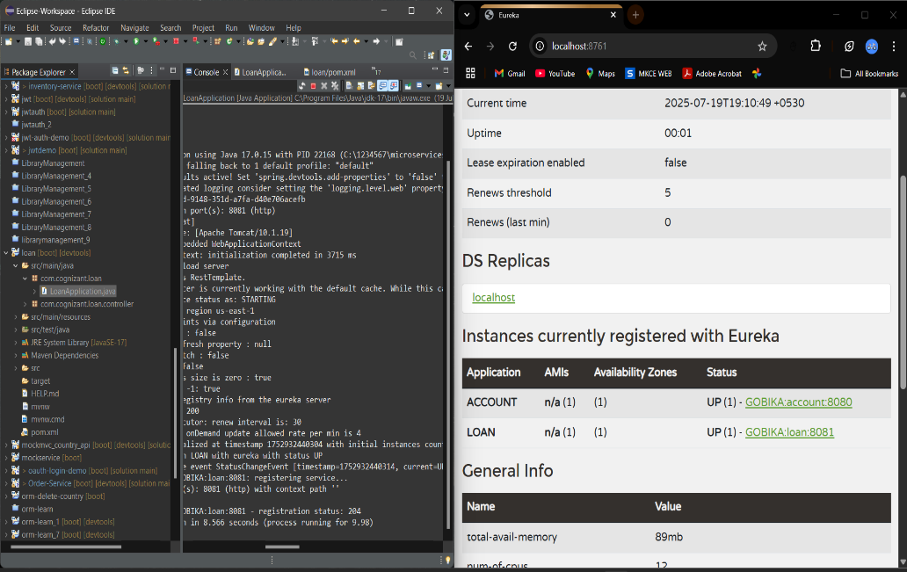

3. Create a Spring Cloud API Gateway and call one microservice thru the API gateway
account
Account
AccountController.java
package com.cognizant.account.controller;

import org.springframework.web.bind.annotation.*;

import java.util.Map;

@RestController
@RequestMapping("/accounts")
public class AccountController {

@GetMapping("/{number}")
public Map<String, Object> getAccountDetails(@PathVariable String number) {
return Map.of(
"number", number,
"type", "savings",
"balance", 234343
);
}
}
AccountApplication.java
package com.cognizant.account;

import org.springframework.boot.SpringApplication;
import org.springframework.boot.autoconfigure.SpringBootApplication;

@SpringBootApplication
public class AccountApplication {
public static void main(String[] args) {
SpringApplication.run(AccountApplication.class, args);
}
}
application.properties
spring.application.name=account
server.port=8080
eureka.client.service-url.defaultZone=http://localhost:8761/eureka
AccountApplicationTests.java
package com.cognizant.account;

import org.junit.jupiter.api.Test;
import org.springframework.boot.test.context.SpringBootTest;

@SpringBootTest
class AccountApplicationTests {

@Test
void contextLoads() {
}
}

api_gateway
application.properties
spring.application.name=api_gateway
server.port=9090

eureka.client.service-url.defaultZone=http://localhost:8761/eureka
eureka.instance.prefer-ip-address=true

# Enable service discovery locator
spring.cloud.gateway.discovery.locator.enabled=true
spring.cloud.gateway.discovery.locator.lower-case-service-id=true

# Optional logging
logging.level.org.springframework.cloud.gateway=DEBUG
greet-service
application.properties
spring.application.name=greet-service

server.port=8081

eureka.client.service-url.defaultZone=http://localhost:8761/eureka

loan
LoanController.java
package com.cognizant.loan.controller;

import org.springframework.web.bind.annotation.*;

import java.util.Map;

@RestController
@RequestMapping("/loans")
public class LoanController {

@GetMapping("/{number}")
public Map<String, Object> getLoanDetails(@PathVariable String number) {
return Map.of(
"number", number,
"type", "car",
"loan", 400000,
"emi", 3258,
"tenure", 18
);
}
}
LoanApplication.java
package com.cognizant.loan;

import org.springframework.boot.SpringApplication;
import org.springframework.boot.autoconfigure.SpringBootApplication;

@SpringBootApplication
public class LoanApplication {
public static void main(String[] args) {
SpringApplication.run(LoanApplication.class, args);
}
}
application.properties
spring.application.name=loan
server.port=8081
eureka.client.service-url.defaultZone=http://localhost:8761/eureka
LoanApplicationTests.java
package com.cognizant.loan;

import org.junit.jupiter.api.Test;
import org.springframework.boot.test.context.SpringBootTest;

@SpringBootTest
class LoanApplicationTests {

@Test
void contextLoads() {
}

}

OUTPUT
